PITS 13402 / SEDL 7584 Test Plan

- Run the following AR command:

ar GlobalServer changeIpdEnabled -change false
- Find a test class in your test environment that has multiple Reporting Class, such as AIG in atgtest3.
- From Trader GUI, create a new straddle strategy as follows. Confirm that the new strategy product is created and it is displayed in the Market Display of Trade GUI.
  - Leg #1: Buy 1 Call
  - Leg #2: Buy 1 Put of the same strike price and expiration date of Leg #1
- Log into CAS
  - Execute following command: casadmin sessionStrategyCache count
  - Note the count of strategies for W_MAIN stragtegies
  - Execute following command: casadmin sessionStrategyCache dump W_MAIN
  - Execute following command: casadmin sessionStrategyCache count
  - Confirm that the count of strategies for W_MAIN is 0
- From SAGUI, launch the Product Definition window
- In Product Definition window, select one of the legs in the new Strategy Product from the Option TAB as below to change the reporting class of Leg #1 (Buy Call leg).

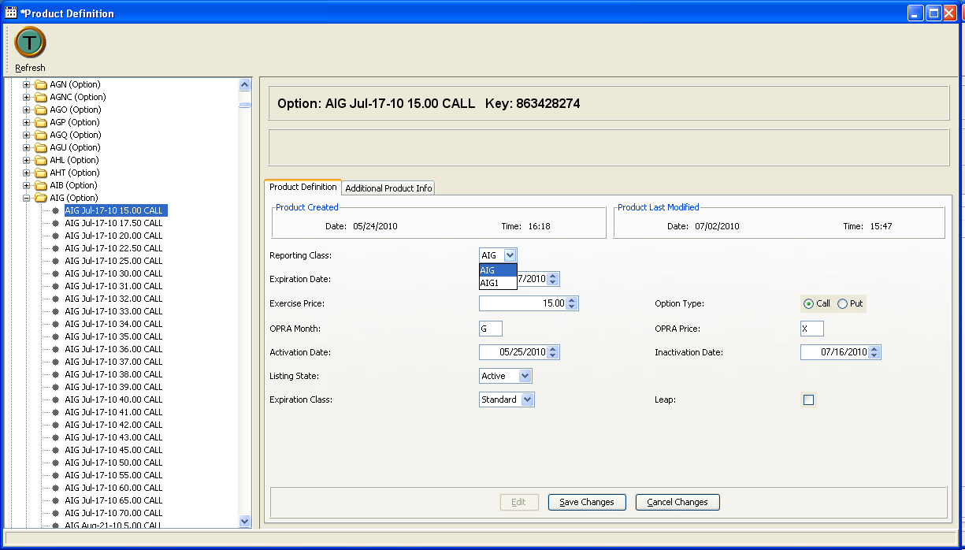

- Using the Trader GUI, attempt to create another strategy with identical leg components as identified in step 3.
- Confirm that a new strategy product is not created, because its leg components are identical to the one defined in step 3. This is can be confirmed from the Market Display window of Trader GUI by checking to ensure that there is only one strategy product definition with same leg components as identified is step 3.
- Repeat this procedure (steps 3 through 9) using different strike price for the Call and Put legs with the following difference in step 6.
  - Instead of changing the reporting class of the Call leg, change the reporting class of the Put leg.

